Hi Dr. Serra,

I think I got some incorrect score for my midterm 1.

Below are the comments for my midterm 1. I am quite do not agree with the points lose in Part A and Part C.

Comments of my midterm 1:

Part A Comments: 1: good, 2: didn't mention performed_by/Performed_on/Owns, 3: should only have listed the PKs once (i.e., leave out contains), 4: Contains relationship does not need FK, Points Taken Away: 3, Part B Comments: CM (3): comment should be an entity, RM (0): consistent with CM, Points Taken Away: 0, Part C Comments: 1: good, 2: good, 3: good, 4: good, 5: don't have person name or ID with each count, Points Taken Away for Queries: 1, Part C RA Comments: all wrong, Points Taken Away for RA: 20, Average Score for Part C: 9.5, Part D Comments: 1: good, 2: good, 3: good, 4: True, 5: good, 6: good, 7: good, 8: good, 9: good, 10: good, 11: False, 12: good, 13: False, 14: good, 15: good, Points Taken Away: 3, Part E Comments: 1: good, 2: good, 3: good, 4: good, 5: good, 6: good, 7: good, 8: good, 9: good, 10: good, Points Taken Away: 0

Argument:

Part C:

|  |  |
| --- | --- |
| The solution | My answer |
|  |  |
| Because we want to know who was born in 1980, I add the  in the RA to choose the first column. | |
|  |  |
| My answer is totally same with the solution. | |
|  |  |
| Because I join person to pet, the column order in RA is different from the solution (but it should not be the reason to lose score); and I think the pet.ID can represent the pet as it is the primary key in Pet, so I only select Pet.ID. | |
|  |  |
| It is the same. | |
|  |  |
| You didn’t give the solution of RA here. But according to the solution of hw2, my answer should be right. | |

Part A:

For the relational types, I think ‘performed by’,’performed on’, and ‘owns’ cannot be considered as independent relations. For example, the relation: ‘owns’, it can be an element in the entity ‘bicycle’. We needn’t to set the ‘owns’ as a single relation. So as the ‘performed by’ and ‘performed on’.

Therefore, I think in this question, think the ‘performed by’,’performed on’, and ‘owns’ are relations or don’t think they are relations are all right.

Evident:

In the PartB, you only set the and  as the relations but didn’t consider the ‘Post’, ‘deal with’ as relations because they can be the elements in other relations.

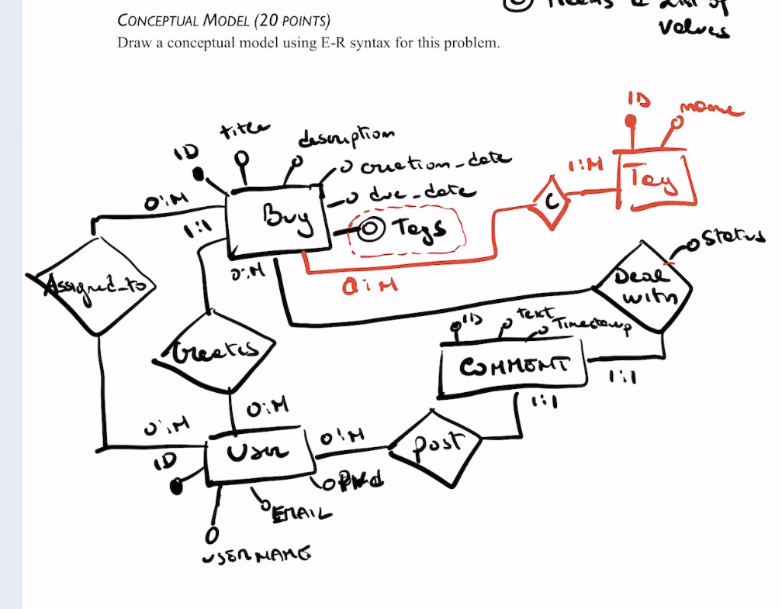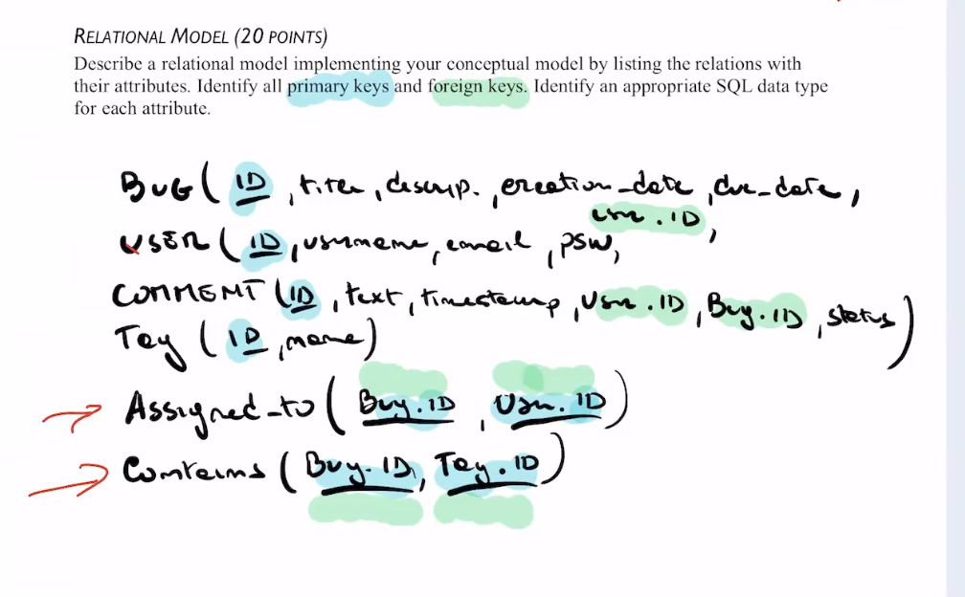

Thus, I want to take the 3 points back in Part A and 20 points back in Part C. Totally 23 points need to get back.

Thanks,

TJ Zhang

11/13/2022